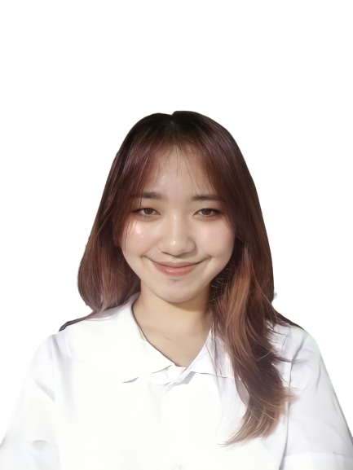**Julia Maribeth D. Ang**

092 Opulencia St. Purok 1 Brgy. Tala Rizal, Laguna

[julia.ang1621@gmail.com](mailto:julia.ang1621@gmail.com)

0955-957-7492

**Personal Data:**

Date of Birth: March 16, 2001

Place of Birth: Calamba, Laguna

Civil Status: Single

Religion: Roman Catholic

Languages/dialects spoken: Filipino, English

**Skills:**

* Proficient with Microsoft Word, Excel, and PowerPoint.
* Know how to use Canva and Adobe Photoshop.
* Have knowledge about C++, Python, and Java programming language.
* Effective written and oral communication skills..
* Adaptive and flexible to all situations.
* A confident and dependable individual with excellent leadership abilities.
* Hardworking, creative, and diligent.

**Educational Attainment:**

**Elementary**

Caingin Elementary School 2007-2013

**Junior High School**

Aplaya National High School ANNEX 2013-2017

**Senior High School**

AMA Computer College Biñan-Campus 2017-2019

**College**

ACLC College San Pablo 2019-2021

Pamantasan ng Lungsod ng San Pablo 2021-present

**Certificates:**

CPA: Programming Essentials in C++ – CISCO Networking Academy

CPP: Advanced Programming in C++ – CISCO Networking Academy

Introduction to Packet Tracer – CISCO Networking Academy

CCNAv7: Introduction to Networks – CISCO Networking Academy